Class Charters
A Class Charter is a set of agreements created by students and teachers that help everyone understand how they can respect each other’s rights. It’s a simple list of rules that help make sure every child’s rights are protected. For example, a charter may include:
Right to Education: “We will make sure everyone has a chance to learn.”
Right to Protection: “We will be kind to each other and never hurt anyone.”
Class charters help children take ownership of their rights and learn how to live by them in their school community.
Why Is This Important? When schools work on the Rights Respecting Schools Award, they are helping children understand their rights and what it means to treat others fairly. It also helps create a positive school culture where every child feels safe, valued, and respected.

How Can You Support Your Child?
- Talk to your child about their rights and what they mean.
- Encourage your child to respect the rights of others.
- Support the school in creating and following the Class Charter.
- Be involved in the school’s work on rights, and encourage your child to share what they learn.
By supporting the Rights Respecting Schools Award, you are helping your child and other children grow in a respectful, safe, and fair environment.

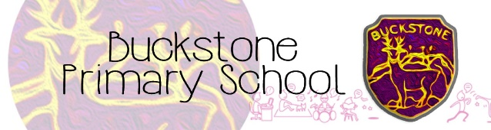
Parents and Carers Rights Respecting Schools
Information Booklet

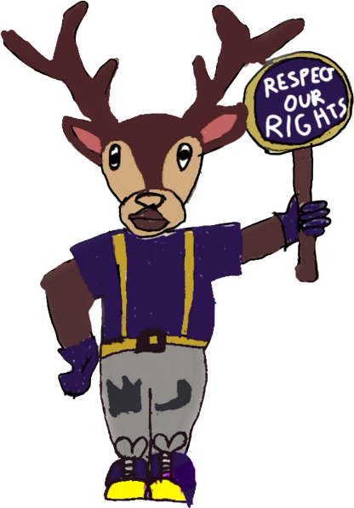

What is the Rights Respecting Schools Award?
The Rights Respecting Schools Award (RRSA) helps schools teach children about their rights and how to respect the rights of others. It is a way to ensure children understand their rights and responsibilities, making Buckstone Primary a fair and supportive environment for all.

We are proud to be a Silver Rights Respecting School, which means we are committed to promoting and respecting children's rights throughout our school, and we are now working hard towards achieving the Gold Award!
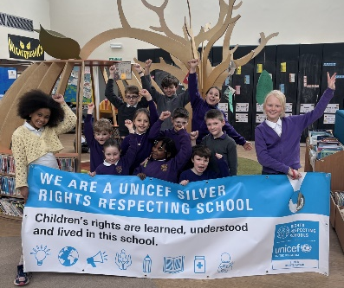
What Are Children's Rights?
Children’s rights are the things that every child is entitled to, simply because they are a child. These rights are about making sure children are protected, treated fairly, and given the chance to grow, learn, and thrive. These rights are laid out in the United Nations Convention on the Rights of the Child (UNCRC).
Key Terms:
Rights Holders: Children are the rights holders. This means they have the right to be treated with respect, have access to education, and be protected from harm.
Duty Bearers: Adults, such as teachers, parents, and governments, are the duty bearers. This means they have a responsibility to respect, protect, and fulfil children's rights.

ABCDE of Rights
The ABCDE of rights is there to show how the concepts of rights being universal, inherent, inalienable, unconditional and indivisible can be explained.
38% of Buckstone parents thought that rights had to be earned! It's important for parents to know that children's rights don't have to be earned because every child deserves to be treated with respect, kindness, and fairness just because they are a person. Rights are something that belong to all kids, no matter what, and they help protect them from harm.
A - ALL children have rights,
B - rights are there at BIRTH
C - rights CANNOT be taken away
D - rights DO NOT have to be earned
E - all rights are EQUALLY important

