
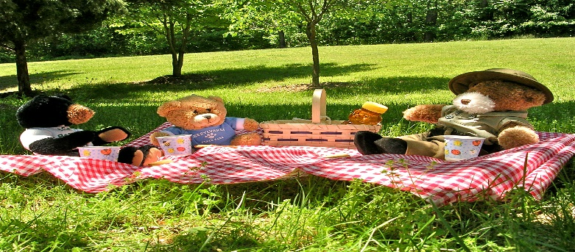

ELC Newsletter – Friday -23/05/25

ELC Blog
Here is the link to the ELC blog:
Early Learning & Childcare – Buckstone Primary School

Hello,

A shorter week for us all and its Friday again! This week many of the children have been spending it outdoors enjoying all the exciting activities on offer, with some lovely dens and shelters made with little pockets all over the garden. Mrs Paris has really made this an exciting place to be. Taking the lead from the children’s play of picnics and tea parties, we have added some resources to support this imaginative experience, adding some water to pour and herbs to mix giving a sensory element to the play. The children interacted so well together, each taking on a role and working together in collaboration.
Indoors the Bears have been loved! Especially the return of our big friend “Huggy wuggy” we have some very cute pictures of children enjoying a snuggle in our quiet area as we welcome him back to our setting. Next week we look forward to Bear themed snack every day! I’m sure your children will tell you all about it. We can’t wait!
Have a lovely weekend everyone.

This week-

Monday-Holiday!
Introducing the transition story “The Everywhere Bear”
Bear themed books and activities
Primary one, imaginative play area to support our pre–school Children

Next week-

Bear themed activities and snack
Continuing with the Transition focus ‘The Everywhere Bear’
Pre School children meeting their Buddy’s
Tea party and picnic play indoors and out
Visits to P1 area for pre-schoolers

FYI-
Some recent information shared from the Care inspectorate-
- This is a great time to remind children and their families of ways to avoid tick bites while outdoors during the summer: Lyme disease is still on the rise in Scotland. It is caused by being bitten by an infected tick and can be serious if not treated. To avoid tick bites when spending time outdoors, stick to footpaths where possible, cover up bare skin with trousers and long sleeves, and use insect repellent on exposed skin. If you or a child is bitten, remove the tick as soon as possible. More information here. Removing ticks as soon as possible is the best way to prevent Lyme disease.

Dates for your Diary

PTA Summer Fair – Saturday 31st May
ELC Garden Tidy up day Friday 6th June “Parent helpers Required”

Term Ends Thursday 26th June

Please do not hesitate to contact us through the school email should you require any further information.
Email: admin@buckstone.edin.sch.uk

