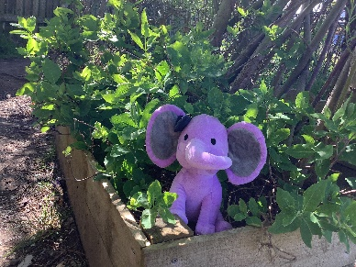

ELC Newsletter – Friday -26/06/25

ELC Blog
Here is the link to the ELC blog:
Early Learning & Childcare – Buckstone Primary School

Hello Everyone,
Here we are on the last day of term.
For some children it’s their last day ever at Buckstone ELC and what a fantastic journey it’s been. We have so many happy memories of our time within the setting and I can tell you it’s been such a privilege to be part of their lives. Thank you. We have shared a slideshow on Clickview capturing just some of our fantastic happy times together at Buckstone, we hope you enjoy sharing this with your child and family.
On behalf of all the staff in the ELC we would like to show our appreciation for all the lovely cards, gifts and most of all final words, as we end for the holidays. There have been a few tears shed this week as some of the children move on to the next exciting chapter in their lives and we wish them all the very best in everything they do. We will miss you all !
Have a brilliant summer break and for those children and families returning following the holidays we can’t wait to do it all again!

This week-

Talking about our highlights and sharing these through the floorbook
Transition conversations
Child led play as they enjoy the final few days together before the holidays
Last day fun!
Happy Holidays!

Dates for your Diary
Term Ends Thursday 26th June at 1pm Following lunchtime.
We will return on Wednesday 13th August 2025

Please do not hesitate to contact us through the school email should you require any further information.
Email: admin@buckstone.edin.sch.uk



