
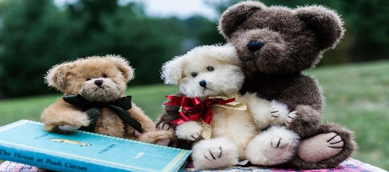

ELC Newsletter – Friday -30/05/25

ELC Blog
Here is the link to the ELC blog:
Early Learning & Childcare – Buckstone Primary School

Hello,

This week, its was all about the Bears as we went on a Transition journey with the ‘Everywhere Bear’ where there was Bears everywhere! We had Teddy Bear pasta shapes for snack and sandwiches filled with honey, they were deeeelicious! The Bears have decorated our walls bringing lots of individual personalities with their colours, patterns and designs. We can really see each child’s creativity shine with so much thought going into each one. We made some that were coloured, painted and we even used collage with each Bear taking on its own personality and style.

As we near the end of the term we are preparing all the children for the exciting changes ahead and the next chapter. The Pre School children are visiting the P1 Play area regularly and meeting their Buddies from Primary 5. Next week they will go on a Bear Hunt with them around the playground. We plan to have lunch in the School Dinner Hall and will continue to support all the children, parents and staff with the exciting changes ahead.

Some of the children have begun to talk all about the beach trip, yes already! We have supported this interest adding some beach provocations to the play such as shells, bucket and spades, and some books all about summer as we look ahead and are now down to weeks before the Holidays. We will explore this season and discussion further next week with some planned Art & Craft activities and sand & water resources.

We have had some a few more cases of the chicken Pox within the setting and School, please continue to be vigilant if your child has not yet had this virus. More information can be found on the National Health Service website and please speak to staff should you have any further questions or enquiries regarding this; we are more than happy to help. www.nhs.uk/conditions/chickenpox/

Can you help us!

On Friday 6th June we have some volunteers from a company coming to support some outdoors groundworks around the School and ELC this coincides with the delivery of some sand and soil for our setting, we are taking the opportunity to give the outdoor space a well needed tidy up as we plan to make this a focus for our environment next term and we want to be ready! We would appreciate any time anyone can spare on this day as the saying goes “more hands make light work” we hope to see you there. There might even be some biscuits!

This week-

Bear themed activities and snack!
Continuing with the Transition focus ‘The Everywhere Bear’
Pre School children meeting their Buddy’s
Tea party and picnic play indoors and out

Next week

Transition for Pre School children including, P1 Area, Dinner Hall, A Teddy Bear Hunt, more fun with our Buddies!
Beach Themed activities as we prepare for our trip.
Parent Helpers Great Garden Tidy Up!

Childs Interest

Making paper Aeroplanes
Using Duplo to create Buildings on Wheels! – We extended this providing some new magnetic Duplo This was very popular!
Dinosaur play incorporating plants and foliage and loose parts such as ramps and logs

Dates for your Diary

ELC Garden Tidy up day Friday 6th June “Parent helpers Required”
Transition Celebration – Friday 20th June (Provisional Time as 11.15am within the ELC) tbc
Term Ends Thursday 26th June

Please do not hesitate to contact us through the school email should you require any further information.
Email: admin@buckstone.edin.sch.uk

