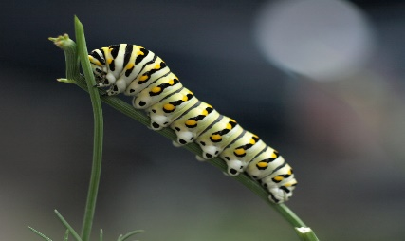

ELC Newsletter – Friday -15/08/25

ELC Blog
Here is the link to the ELC blog:
Early Learning & Childcare – Buckstone Primary School

Hello Everyone,

Welcome back! It’s been so lovely to all be back together within our setting. This week we have shared our news with each other, and I can tell you a highlight from most pupils was eating ice cream!
We have begun to welcome our new families into Buckstone and we look forward to getting to know them over the following weeks.
This week we have been lucky to enjoy some more lovely summer weather. Thank you for your ongoing support in providing suncream for your child and applying it prior to attending the setting. We will reapply this when required following lunchtime.
This week we learned that lots of Caterpillars were enjoying the kale growing in the planter outside in the school playground. We observed them eating “ALL” the leaves and just like the story, they were very hungry. As the children were fascinated by seeing so many on the leaves, “billions” and “trillions” they said, we brought some into the setting to watch for any changes. We are excited to see them change into butterflies and we already some making their cocoons. We have supported this interest with some books, stories and learning about metamorphosis on the smart board. Over the following weeks we will learn about butterflies as we watch this process of nature together. It’s exciting!

To support some of our new children’s interests Mrs Paris has created a fabulous dinosaur area with jungle like natural materials, this play has been extremely popular and enjoyed by many of our children over the last few days.

Can you help us! – We are looking to develop a family wall for our pupils, if possible, can you please send into the school admin Email address below, a picture of your child and the members of their family to add to our display within the setting. Thank you in advance!
admin@buckstone.edin.sch.uk

This week-

Settling Back into the ELC
The Colour Monster book focus
Sharing our news
Child led play
Welcoming our new families

Next Week-

Caterpillars and Butterflies – Learning about the lifecycle
Settling our new families
Developing our family wall
Introduction to Simoa (Care commission purple elephant) - Safe, Inspect, monitor, Observe, Act
Dates for your Diary

Autumn Holiday – Monday 15th September
Midterm – Monday 13th October -All resume -Tuesday 21st October

Please do not hesitate to contact us through the school email should you require any further information.
Email: admin@buckstone.edin.sch.uk



