
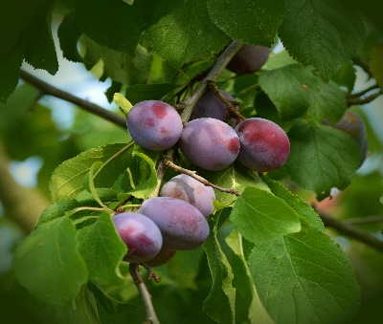

ELC Newsletter – Friday -05/09/25

ELC Blog
Here is the link to the ELC blog:
Early Learning & Childcare – Buckstone Primary School

Hello Everyone,

What a fantastic week we have had within our setting, it’s been great getting to know our new children and families and were just so proud at how quickly they have settled into Buckstone and new positive friendships are being formed so quickly.

With the change in weather and a few wetter days last week it would be fantastic if children can have some wellington boots on these days to truly embrace the elements.

Thank you all so much for sending in the beautiful family pictures these have been added to our ‘Belonging Wall’ as we support the children and their families to feel connected, there is still a few more to receive please do send these on admin@buckstone.edin.sch.uk

Following the interest in this area we would like to include any family pet pictures into our home corner please send on individual pictures with a pet name to our admin email, thank you in advance!

We hope you have all got access to your child’s Online Learning Journal there has been some observations and learning stories recorded from the beginning of this term. Please speak to staff if you require a reset or any support to login.

This week-

Introduction to our Colour groups Keyworkers and morning welcome
Learning all about how our Elephant Simoa can help us to stay safe around our setting
Bingo games!
Cooking ideas in the mud Kitchen

Next week

Learning about our Buckstone values “Ready, respectful and safe”
Woodwork area introduced as we learn to use using tools carefully
Puppet theatre and a focus on retelling stories using props
Pen drawings

We are looking for more junk boxes for our gluing area, please recycle any packaging you may have, and we will return it as a model!

Childs interest-

Using puppets to retell a story
Mixing paints to create new colours- we will provide a mixing station to support this creativity

Please can you donate a box of tissues for the setting our supplies are running low! Thank you.

Dates for your Diary

Autumn Holiday – Monday 15th September
Midterm – Monday 13th October -All resume -Tuesday 21st October

Please do not hesitate to contact us through the school email should you require any further information.
Email: admin@buckstone.edin.sch.uk

