
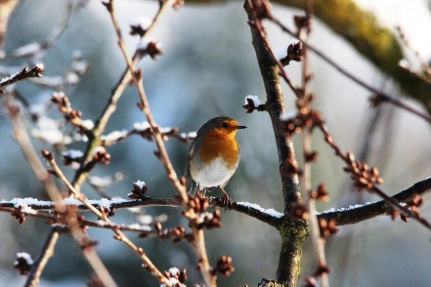

ELC Newsletter – Friday -16/01/26
ELC Blog
Here is the link to the ELC blog:
Early Learning & Childcare – Buckstone Primary School

Hello,
This week it’s been lovely to welcome our new families into our setting; we have been so impressed at how they have just fitted right in and how amazing our children have been at helping them feel right at home with many children taking them by the hand to play as they become “The big ones”.
This week there has been some fantastic building and construction using the large Blocks with some observations made of the children building computers and laptops, we extended this interest adding some keyboards into the setting and the children just loved having the opportunity to type onto the smartboard, with many children spelling out their names, we will continue this interest next week with a literacy focus around recognising phonics.
Many children have loved getting back to their creative space and this area has been a hive of activity, we responded to the use of this area by opening up the space with the addition of an open bookshelf to display our junk and loose parts please continue to supply recycled boxes and packaging to keep up with the demands of the little artists this is greatly appreciated by all x

This week

Zones of Regulation-How are you feeling
Settling New Children
Feeding the Birds-Moving towards-The RSPB Big Garden Birdwatch 2026
Winter weather
Playing in the snow!

Next week

Creating our Winter learning wall
Big Garden Birdwatch 2026
Introducing Rabbie Burns and Learning some Scottish words!
Children’s interest in Computer Keyboards

Childs interest-
Writing words using a computer Keyboard

Dates for your Diary

Mid-term Holiday- Monday 16th February-20th February
Friday 3rd April-Good Friday
Monday 6th April-Easter Monday
All resume-Tuesday 21st April

Monday 4th May Holiday Tuesday 5th May Staff In service Day
All resume Wednesday 6th May

Please do not hesitate to contact us through the school email should you require any further information.
Email: admin@buckstone.edin.sch.uk

