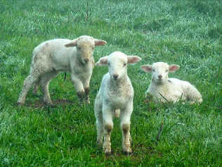


ELC Newsletter – Friday -27/03/26

ELC Blog
Here is the link to the ELC blog:
Early Learning & Childcare – Buckstone Primary School

Hello,
On Monday we enjoyed an Eid celebration as Mrs Lahmidi and some of our pupils shared how they had enjoyed this important day at home and some of the traditions shared together. We ate a sharing snack of freshly baked biscuits cut in the shapes of stars and moons. This is very symbolic for this religion.
This week the children have enjoyed exploring the new farm area, exploring some of the sensory materials added for the animals to enjoy, some mud and hay. We have begun to explore this spring season noticing the changes outdoors and the new buds appearing. We hope to go a local walk next week to look for ‘Signs of Spring’ as we learn about some of the flowers appearing over this time.

This week

Eid Celebration – Monday 23rd March
Local walks
Springtime Activities
Farm

Next week

Springtime activities
Learning about Easter
Eggs shape focus

Dates for your Diary

Friday 3rd April-Good Friday
Monday 6th April-Easter Monday
All resume-Tuesday 21st April

Monday 4th May Holiday Tuesday 5th May Staff In service Day
All resume Wednesday 6th May

Please do not hesitate to contact us through the school email should you require any further information.
Email: admin@buckstone.edin.sch.uk

