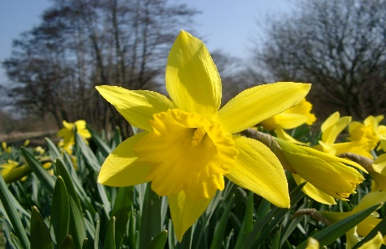



ELC Newsletter – Friday -24/04/26

ELC Blog
Here is the link to the ELC blog:
Early Learning & Childcare – Buckstone Primary School

Hello,
It’s been lovely to welcome you all back into the setting, we hope you had an enjoyable Springtime break.

This week the children helped to select some resources to change the interest within the water tray. They were happily choosing people, boats, nets and some fish to be added and this has been a very popular area of play this week.
Outdoors many of the children have been noticing some bugs and insects such as the ants and a butterfly as we introduce them to more minibeasts at our interest table. We have added some lovely stories to support this learning and will enjoy these over the following week. We have planned to participate in some planting activities to encourage more insects and wildlife to our outdoor area.
We have welcomed the sunshine over the last week helping us to enjoy lots of time outdoors. Next week we will ensure all suncream application letters are re-issued. Please ensure your child is provided with an unopened bottle of Suncream with a preference for SPF 50 and labelled, so it can be kept within the setting. Thank you for your ongoing support and understanding with the Policy.

This week
Welcome Back!
Children’s choice to resource areas
Minibeasts

Next Week
Minibeast area and Tuff tray activity
Planting and growing

Children’s interest
Minibeasts

Dates for your Diary

Monday 4th May Holiday Tuesday 5th May Staff In service Day
All resume Wednesday 6th May

Please do not hesitate to contact us through the school email should you require any further information.
Email: admin@buckstone.edin.sch.uk

