
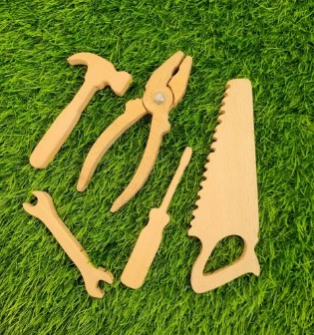

ELC Newsletter – Friday -04/09/26

ELC Blog
Here is the link to the ELC blog:
Early Learning & Childcare – Buckstone Primary School

Hello everyone,

September already! This week the children have really enjoyed extending their interest in tools and building, as these resources were added to our block area, through observation we have developed their interests adding resources as required such as a toolbox and hard hats, this play has been very much enjoyed and the building work within the setting is progressing well! Next week we will introduce the group to our woodwork area whereby they can explore the real tools and equipment, what fun!
Thank you very much for your kind donations of tissues, this is very much appreciated and will be well used!

This week

Welcoming new children
Introducing Personal Plans to our families
Exploring our zones of regulation and Emotions using The Colour Monster
Farm to Fork-Learning about where foods come from

Next Week

Pen drawings and All about me pictures for their personal plans.
Developing our family’s wall space
Building site Interest
Introducing the woodwork area
Sharing the School Values -Ready, Respectful & Safe

We have sent every child home a template card to create a winter celebration card should you will these should be returned no later than Friday 11th September, with Thanks.

Dates for your Diary-

Autumn Holiday – Monday 14th September
Mid Term Break – Monday 12th October- All resume Tuesday 20th October

Please do not hesitate to contact us through the school email should you require any further information.
Email: admin@buckstone.edin.sch.uk

