
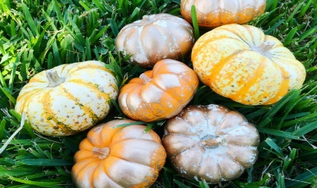

ELC Newsletter – Friday -09/10/26

ELC Blog
Here is the link to the ELC blog:
Early Learning & Childcare – Buckstone Primary School

Hello everyone,
This week in our setting we have embraced the change in the season and have been exploring all things Autumn, with experiences available such as: painting with Autumnal colours, gluing with natural materials, counting with conkers, exploring the Autumnal interest tuff tray, stories reflecting the season such as “The Leaf Thief”, exploring the forest animals such as hedgehogs, squirrels, and foxes through our small world and puppet areas, going on a scavenger hunt using our Autumn checklist. We finished off our week with a fantastic whole group walk to the woods where we had a lovely picnic snack together. These are just some of the planned experiences on offer in our setting this week. It’s really such a lovely season to enjoy. We hope you all get a chance to get outdoors and appreciate some of the lovely autumnal colours through this changing season and October mid term break. We would love to see anything collected on your walks and look forward to seeing you all very soon x

This week

Pre School Consultations with Keyworkers
Autumn experiences across the setting
Autumnal local walk
Autumn scavenger hunt in our Keyworker groups.

Next week

Midterm Break-Pupils return on Tuesday 20th October

Childs Interest-Drawing on large carboard Boxes- Watch this space!

Dates for your Diary-
Mid Term Break – Monday 12th October- All resume Tuesday 20th October

Please do not hesitate to contact us through the school email should you require any further information.
Email: admin@buckstone.edin.sch.uk

