
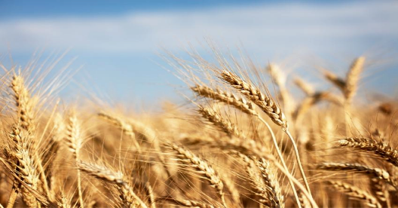

ELC Newsletter – Friday -11/09/26

ELC Blog
Here is the link to the ELC blog:
Early Learning & Childcare – Buckstone Primary School

Hello everyone,
This week the children have thoroughly enjoyed extending their interests in building sites and worker roleplay, with areas provided outdoors as well as in. This interest was transported to the sand area and many of the diggers and a whole lot of water ended up in there! We plan to enjoy this more at this area of play as we add some fresh sand today!
This week we achieved a lot with the children participating in their black pen drawings and helping to create a card. All the children really enjoyed this art opportunity we will be uploading images to their Online Learning Journals with our focus on Literacy. We are particularly capturing their individual stages with fine motor control. Please let us know if you’re having any issues logging into the journals as a reset can be sent out easily.
As we have begun to observe some falling leaves outdoors, we have introduced the children to the Season of Autumn, through our books, stories and a lovely display which we will add to throughout this season as the changes in colours occur. We would love it if the children could collect any items of interest to enhance this space, Ms Graham especially loves Conkers! We would love as many as you can find fallen on the ground using these as our loose parts provision within the home and mud kitchen areas. Happy Autumnal walks everyone and have a lovely long weekend!

This week

Pen drawings and All about me pictures for their personal plans.
Developing our family’s wall space
Building site Interest
Introducing the woodwork area
Sharing the School Values -Ready, Respectful & Safe

Next Week

Monday Holiday-14th September
Building site play in the sandtray
Child smile story telling with Mrs McNee
Individual Photographs-Thursday 17th September
Introducing the season of Autumn
Exploring wheat and learning about where flour comes from -Little Red Hen Book Focus

Dates for your Diary-

Autumn Holiday – Monday 14th September
Mid Term Break – Monday 12th October- All resume Tuesday 20th October

Please do not hesitate to contact us through the school email should you require any further information.
Email: admin@buckstone.edin.sch.uk

