
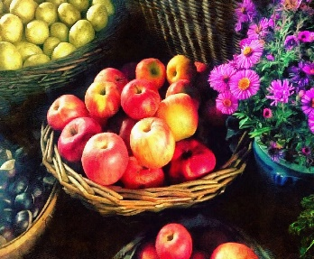

ELC Newsletter – Friday -28/08/26

ELC Blog
Here is the link to the ELC blog:
Early Learning & Childcare – Buckstone Primary School

Hello,
What a lovely week we have had with our new children settling in so well. We have explored some of the emotions and feelings we have felt. We have been supporting the children to understand these feelings using the story “Pete the Cat and his Magic Sunglasses” with props to retell the story.
This week we have continued to explore all the apples that we collected last week using our observation skills to count, sort and describe the various colours and varieties. We have been choosing our favourite ones to draw, paint, and glue and we have been adding these onto our apple wall display! Have a look which colour did your child choose?
Next week for snack we have ordered a large variety of fruits as we learn how they are grown.

The fundraising packs have arrived for the ELC and families to complete a Winter celebration card. There is an early return date of 16/09/26. The ELC will enjoy completing one within our setting with the option of one from home too - ordering cards is optional once the sample form is here.

This week-

Welcoming new children.
Introducing Personal Plans to our families.
Exploring our Zones of Regulation and Emotions using The Colour Monster.
Farm to Fork-Learning about where foods come from.

Next week

Self-regulation morning check in.
Using our new picture sticks with the zones of regulation area.
Childs interest, “Owl Babies” story sack at our listening station.

Dates for your Diary-

Autumn Holiday – Monday 14th September
Mid Term Break – Monday 12th October- All resume Tuesday 20th October

Please do not hesitate to contact us through the school email should you require any further information.
Email: admin@buckstone.edin.sch.uk

