
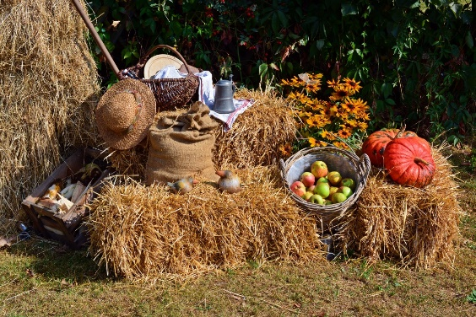

ELC Newsletter – Friday -18/09/26

ELC Blog
Here is the link to the ELC blog:
Early Learning & Childcare – Buckstone Primary School

Hello everyone,
A shorter week for us all, but busy and fun filled all the same.
The children enjoyed their return with many sharing their news. Thank you very much for sharing this on their Online Learning Journals. We have shared these with the group and celebrated some personal achievements placing these pictures on the wall as recognition. Please keep sharing and we will keep celebrating their news.
On their return the children helped to prepare some fresh playdough with the group choosing a purple shade, a popular Buckstone colour! Miss Blain worked with them to discover what colours we could mix to create this, and we were very impressed with the results! This area has been very popular this week - maybe the added colour made it a little more interesting.
A parent handed in some dinosaur wallpaper which the children were immediately attracted too, reviving some interest in this imaginative area. We have developed this area further adding some books and creating a dinosaur land for all to explore as we try to learn and identify some species.
The children did very well for their school photographs. For some, this was a first-time experience. Let’s hope the results show how well they all did taking it all in their stride, well done!

This week

Monday Holiday-14th September
Building site play in the sand tray
Child smile story telling with Mrs McNee
Individual Photographs-Thursday 17th September
Introducing the season of Autumn
Exploring wheat and learning about where flour comes from -Little Red Hen Book Focus

Next week
Dinosaur theme
Learning about wheat and making bread
Autumn Seasonal activities

Dates for your Diary-
Mid Term Break – Monday 12th October- All resume Tuesday 20th October

Please do not hesitate to contact us through the school email should you require any further information.
Email: admin@buckstone.edin.sch.uk

